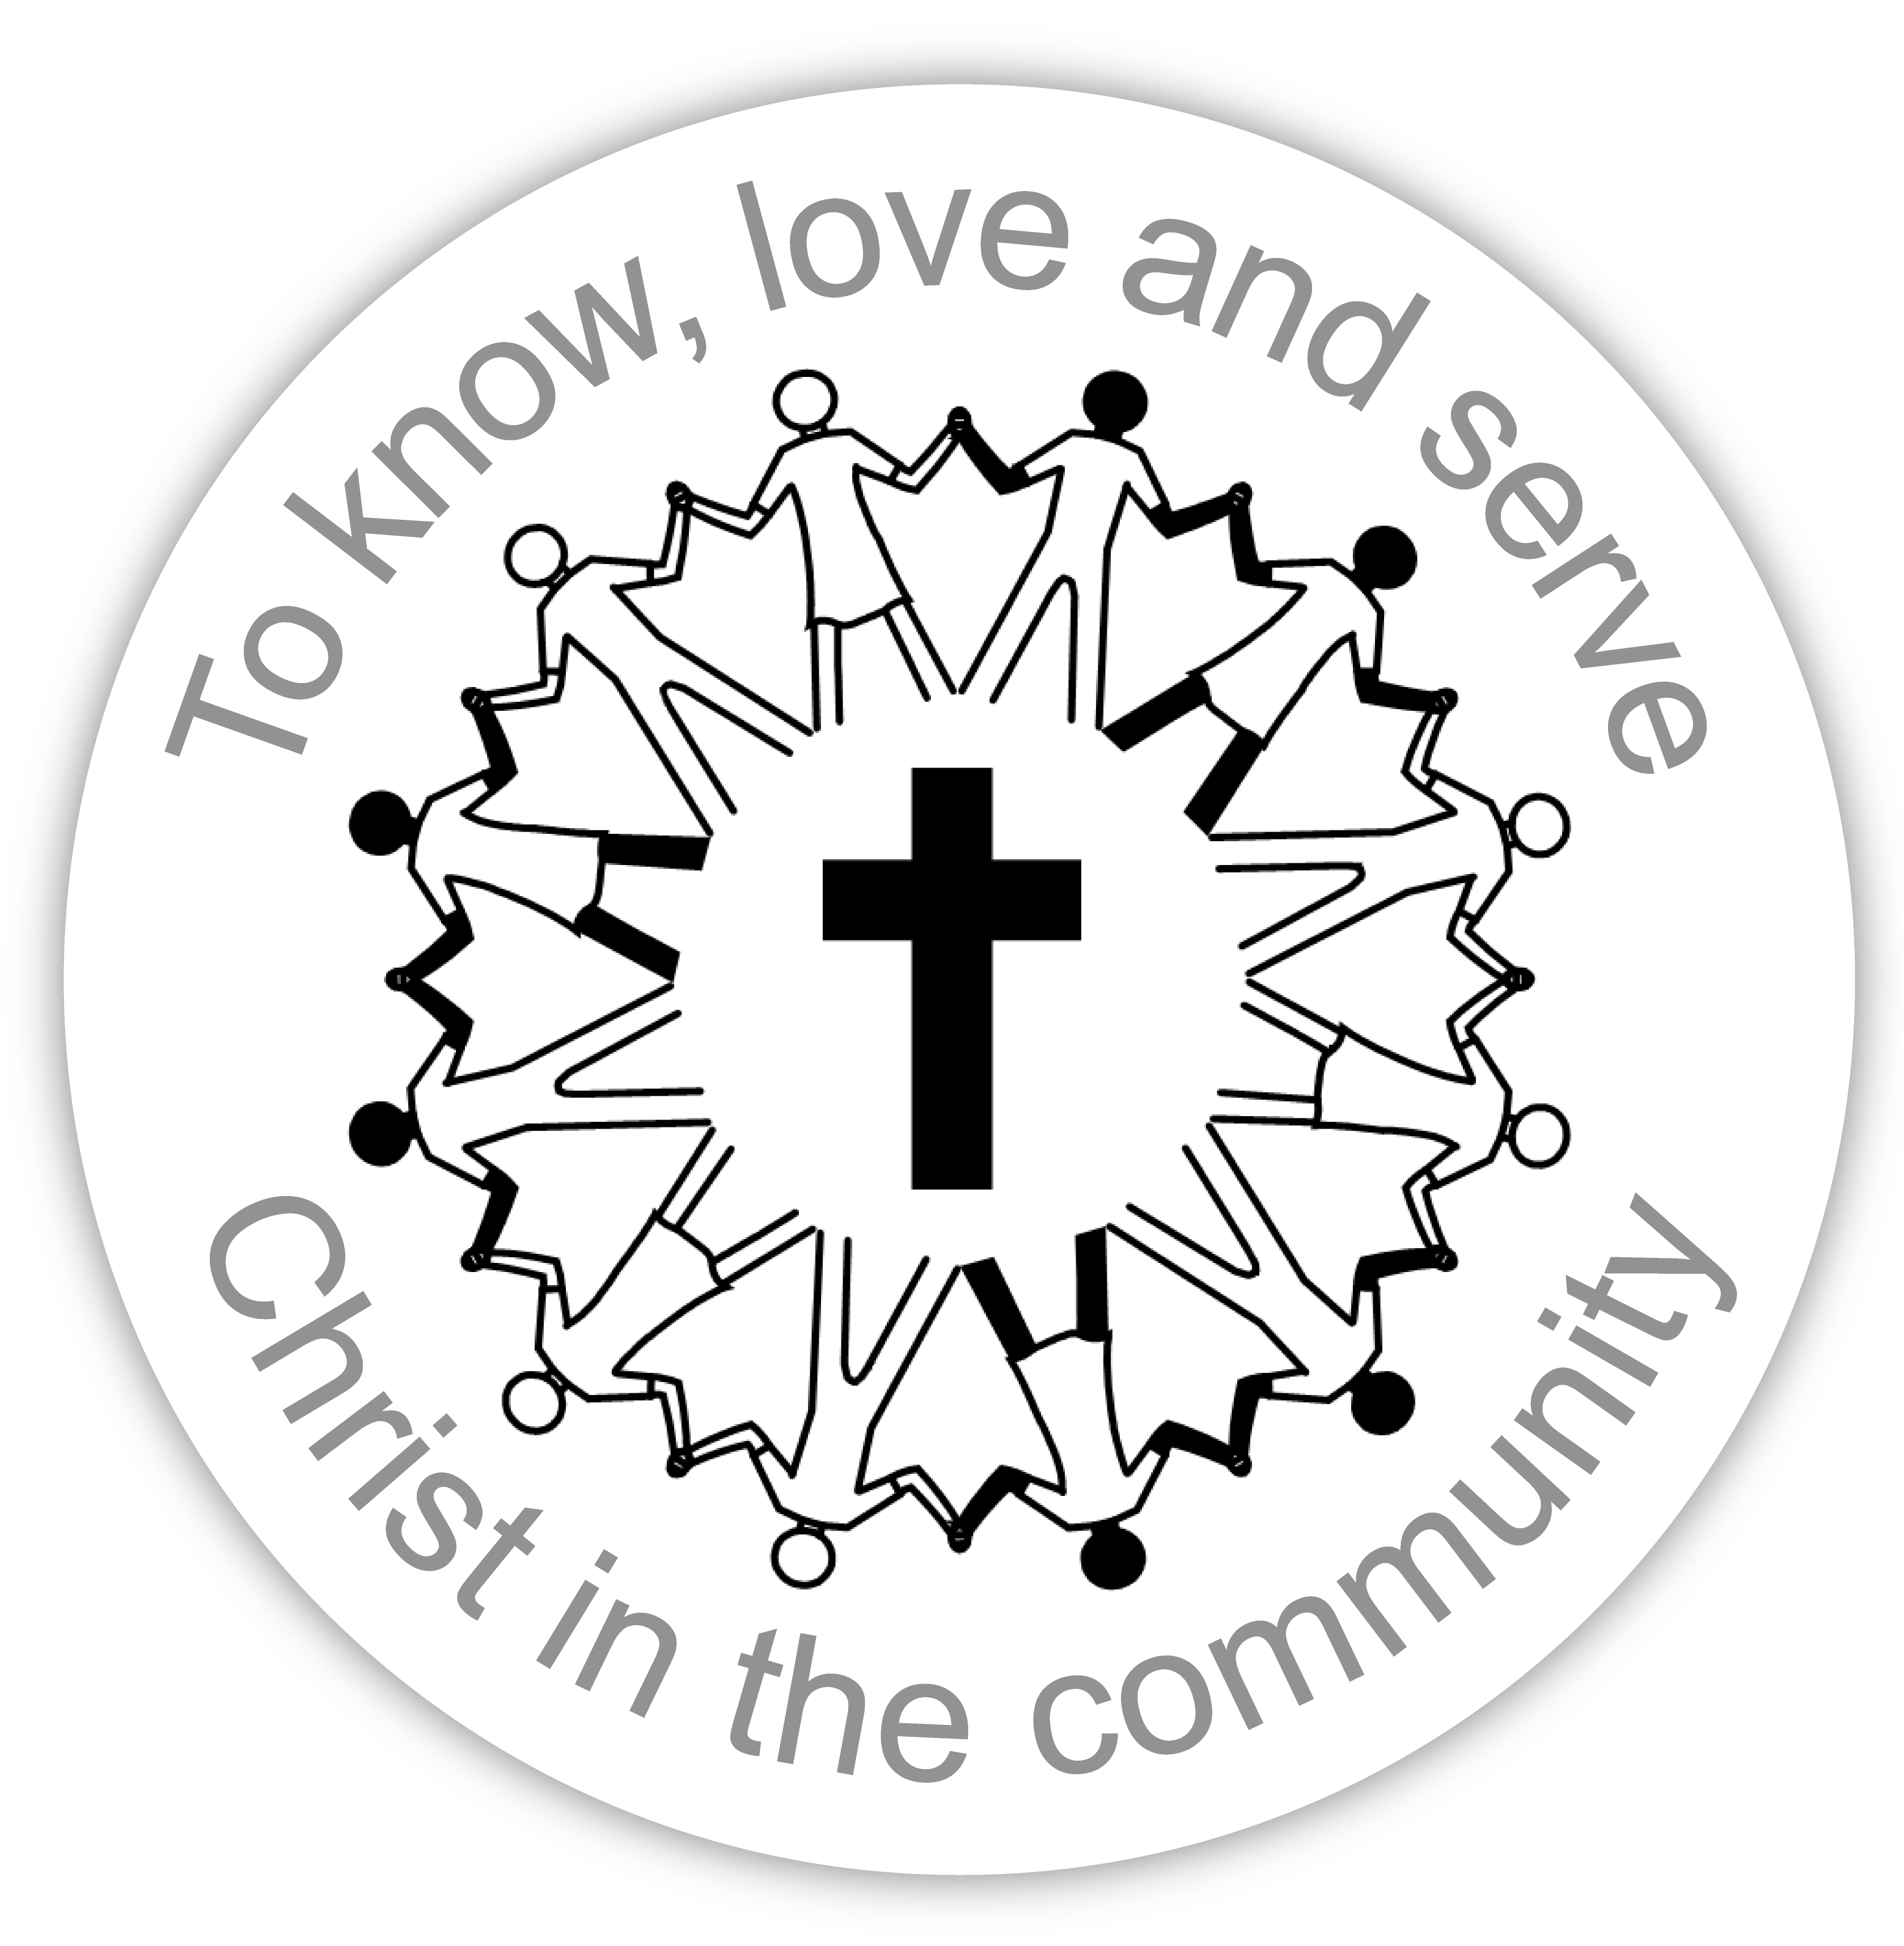
APPLICATION FOR BAPTISM /
MEMBERSHIP
Of CHATSWORTH BAPTIST CHURCH

Please complete, using BLOCK LETTERS, and return to the church office

Surname ______________________________________ Mr. Mrs. Miss or other _________

Forenames ________________________________________________________________

Address ___________________________________________________________________

__________________________________________________________________________

Telephone Number __________________________________________________________

Email address

I agree that this can be published in the church members’ handbook (or cross this through)
YES NO

Is this application for baptism only?

Is this application for baptism and church membership?

Or for membership only*?

*If the application is for membership only, please complete the following:
- If you have been baptised as a believer by total immersion

Date baptised _________________________________________________________

- If transferring membership from another church please give the following details,
Name of church where previously in membership:

____________________________________________________________________

Address of Church: ____________________________________________________

____________________________________________________________________

This section to be completed by the Applicant (if application is for church membership):

Having received a copy of the Statement of Belief and Church Rules:

~ Do you accept these and agree to abide by them? ________________________

~ Do you promise to serve the Kingdom of God in and through Chatsworth according
to your opportunities, gifts and calling?________________________

Signature____________________________________ Date ________________________

Thank you for filling in this form. Our Church Roll Registrar, Miriam Taylor, will contact you shortly.

Revised June 2015 Chatsworth Baptist Church Registered charity no: 1131202

