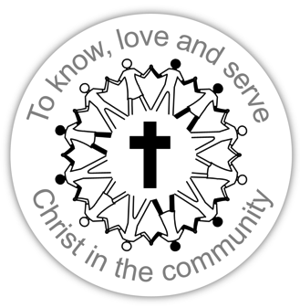
Chatsworth Baptist Church
Chatsworth Way
London, SE27 9HN

020 8761 0011
office@chatsworthbaptist.org.uk
www.chatsworthbaptist.org.uk

Chatsworth Baptist Church
To know, love and serve Christ in the community

__ My gift is enclosed

__ Please let me know when I should make my gift

__ Please contact me to let me know how I can make my gift

My contact details ____________________________________________________________________________________________
I ______________________________________

would like to make a Gift of £_______________

Do you pay tax in the UK? If you haven’t already, please fill
in the enclosed Gift Aid form for us to claim back the tax
on your gift.
__ I have already set up my pledge

__ Please let me know when I should set up my pledge

__ Please contact me to let me know how I can make my pledge

My contact details ____________________________________________________________________________________________
I ______________________________________

would like to Pledge £________________ every month
for ____ year(s).

Do you pay tax in the UK? If you haven’t already, please fill
in the enclosed Gift Aid form for us to claim back the tax
on your gift.
__ Please provide me with details of how a loan would work

My contact details ____________________________________________________________________________________________
I _____________________________________

would be willing to Loan £________________
for a period of _____ year(s), interest free.

How to give:
Cash:
We will take a Special Offering on Sunday 31 July

Cheque:
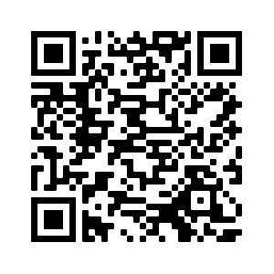
Made payable to Chatsworth Baptist Church

Online Gift:
You can make a one off online gift via Stewardship Services here:
https://account.stewardship.org.uk/donation/oneoff/20153966 or use the QR code

Please give reference ‘Gift Day’

Standing Order:
Gift Aid
If you pay tax in the UK, the government will give an extra 25% of your gift to the church!

If you have not already done so, please fill in the enclosed Gift Aid form.

To set up a regular amount each month, a Standing Order is best.
Our bank account details are:
Chatsworth Baptist Church RCN 1131202
​
Sort code: 09 07 24
​
Account number: 50537080

Please give reference ‘Gift Day’

Loan:
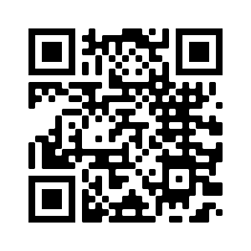
Please contact us for more details

Giving details can also be found on our website www.chatsworthbaptist.org.uk

